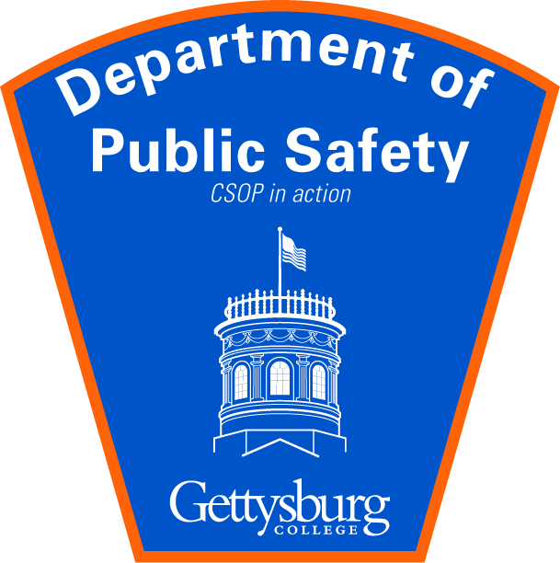

Guest Parking Pass
MD-PA/APRA Conference
Valid June 07, 2018
Constitution Parking Lot or Stone Lot

